SARDAR VALLABHBHAI NATIONAL INSTITUTE OF TECHNOLOGY, SURAT
DEPARTMENT OF CIVIL ENGINEERING
GEOTECHNICAL ENGINEERING SECTION
ADVANCED GEOTECHNICAL LABORATORY
Advanced Geotechnical Laboratory was established in the year 2022. The laboratory is located in the Advanced Research Centre (ARC-006), Department of Civil Engineering. The laboratory facilities are utilized by undergraduate and postgraduate students for their project and research work. The Ph.D. scholars also utilize it for the research and development activities. It is one of the key laboratory for PG and Ph.D. programmes working with majority of available set ups. The laboratory has good potential to carry out research and also generate revenue through consultancy & testing work. List of equipment available in the laboratory is given below:
Sr. No. | Equipment Name
1 | Cyclic Triaxial Test Apparatus
2 | Dynamic Actuator
3 | Loading Frame (5T)
4 | Canon DSLR Camera
5 | Tanks with transparent side
6 | Falling Weight Deflectometer
7 | Bump Integrator
8 | Loading Frame (10T)
9 | Reaction frame and model tank with Load Cell & LVDT
Information Regarding Few Important Set Ups in the Advanced Geotechnical Laboratory
Cyclic Triaxial Test Apparatus:
Cyclic Triaxial testing is performed on soil and road material when it is necessary to evaluate their stiffness and deformation properties under cyclic loading conditions. These conditions might include dynamic loading coming from earthquakes, passing vehicles and trains, sea waves, wind, vibration machines etc. There are many variations of Cyclic Triaxial test methods and the user should select the one that is most accurately simulating the conditions in the field. A Cyclic Triaxial apparatus is an advanced version of a static Triaxial system. The instrument has a loading capacity of 5 kN with operating frequency up to 5 Hz. The sample size of 50mm and 100mm diameter can be tested in this apparatus. The photograph of Cyclic Triaxial system is shown in Figure 1.
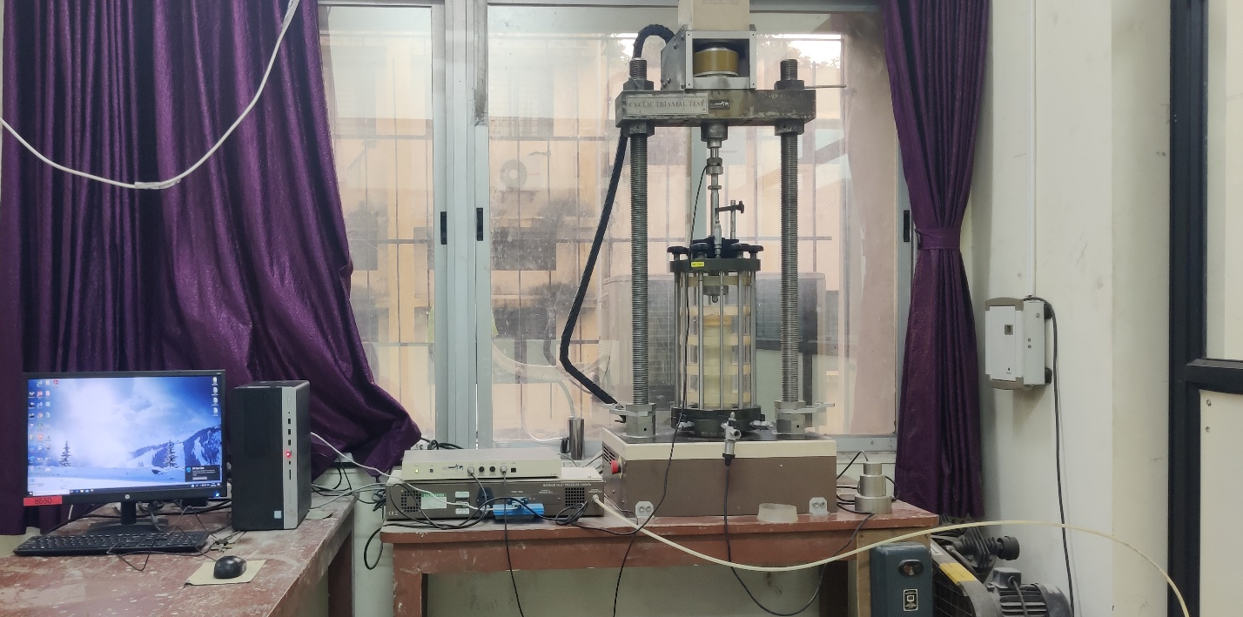
Figure 1 Cyclic Triaxial Apparatus
Dynamic Actuator:
The dynamic actuator is dedicated designed for fatigue or dynamic tests which needed quick response. This kind of actuator adopts double rods double action structure with equal piston area. The instrument has a 30kN capacity and a frequency range of 38 to 100 mm. The photograph of a typical Dynamic Actuator is shown in Figure 2.
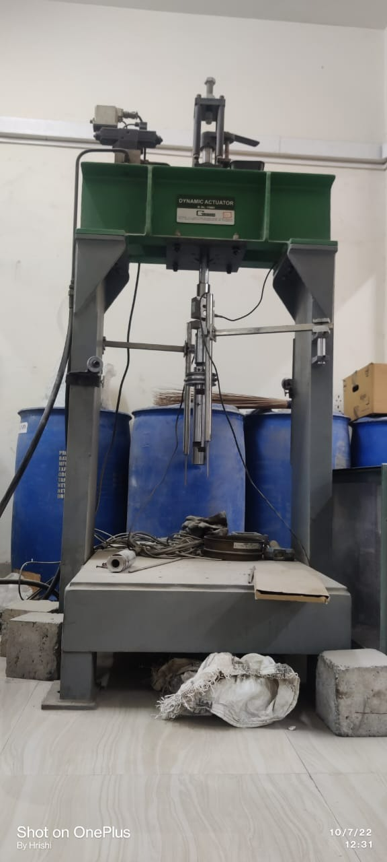
Figure 2 Dynamic Actuator
Loading Frame (5T):
The loading frame is used to simulate a number of geotechnical engineering problems like penetration problems, arching simulations, offshore problems, uplift problems, laterally loaded structures, etc. The scaling effect is negligible using the loading frame.
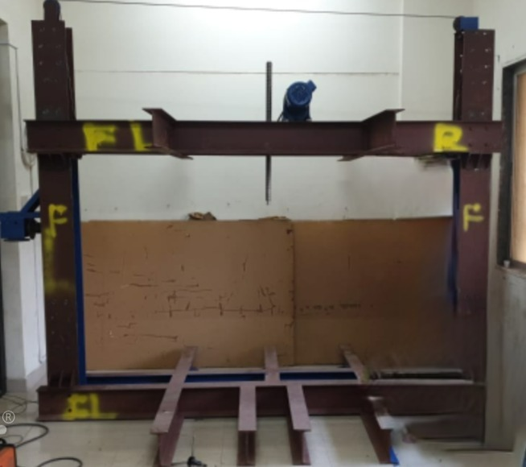
Figure 3 Loading Frame (5T Capacity)
Canon DSLR Camera:
A Canon EOS 200D-II DSLR camera with a zoom lens, f/4-5.6, EF-S18-55mm focal length contains a 24.1-megapixel APS-C complementary metal-oxide-semiconductor (CMOS) sensor of size 22.3 x 14.9 mm. The camera is used to capture images of experimental simulations of geotechnical engineering problems that will analyzed using PIV-DIC algorithms.
Figure 4 Canon DSLR Camera
Tanks with transparent side:
Four tanks of different sizes that can be used for experimental simulations of almost all geotechnical engineering problems without having scaling effects. The front side of the tanks is made up of acrylic sheet which allows to capture images while performing the experiment for image analysis study.
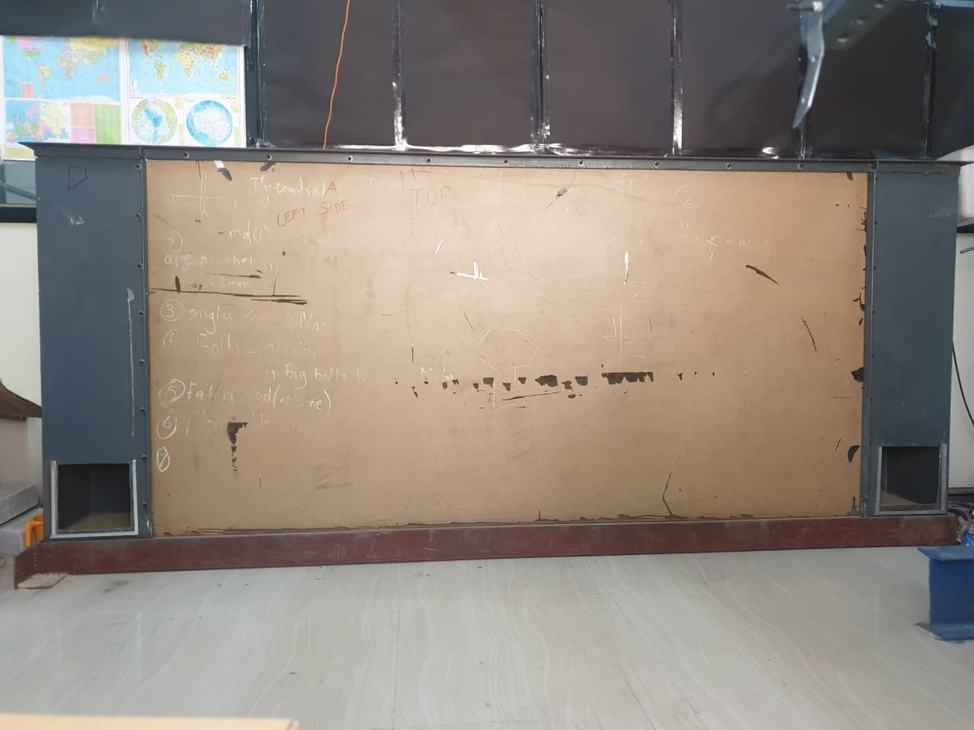
Figure 5 Tanks with transparent side
Falling Weight Deflectometer:
The Falling Weight Deflectometer (FWD) is an integral part of the process for structural evaluation of pavements and for a good reason. The FWD is a non-destructive and fast method to evaluate the structural capacity of pavements for research, design, rehabilitation of the road and for pavement management purposes. The Dynatest Falling Weight Deflectometer (FWD) applies a dynamic load that simulates the loading of a moving wheel. The pavement response is analyzed with Dynatest’s ELMOD (Evaluation of Layer Moduli and Overlay Design) software to determine the elastic moduli, stresses, and strains of each modeled layer. ELMOD reports the weakest layer of failure, residual life and determines the optimum rehabilitation alternatives. The FWD is available as a trailer or a truck-mounted version (the USA only) meeting all FWD standards worldwide. Loading Capacity up to 150 kN, quad-segmented loading plate of 300 mm diameter accompanied with 7 geophones, fully operated with laptop, ELMOD 6 software for back-calculation.

Figure 6 Falling Weight Deflectometer
Bump Integrator:
A bump integrator is a tool used in the rear of vehicles, it analyzes unevenness in roads, which one can quantify using digital counters embedded in an LCD screen. An Integrator is a low-cost device fitted onto the back of a trailer that helps measure the irregularities on roads while driving. The trailer connects to a rubber tyre via chassis. It contains an integrating device that tracks surface irregularities, so it measures via digital counters arranged on an LCD screen on the panel. The working principle of bump integrator is about measuring the vertical deflection of a pneumatic tire due to road irregularities and integrating the readings over a specified time interval, and displaying the results on an LCD screen in digital format. The bump integrator, using an air pressure sensor, the device measures the road bumps on highways. The pneumatic tire is somewhat different from an average car or bike tyre.

Figure 7 Bump Integrator
Loading Frame (10T): -
Load frames testing utilizes a high stiffness support structure against which the test forces can react. The load frame comprises a base beam, two columns, and a moving crosshead that when fitted with fixtures can measure different mechanical properties related to strength and displacement. It can be used to test different structural elements like columns, beams, frames as well as model studies can be conducted on various geotechnical areas like slope stability, pile foundation, retaining wall many more.
The frame is fabricated from standard rolled sections for assured strength. The skeleton of basic frame is designed as self-straining where no load is transferred to the ground except self-weight of the frame. Has load carrying capacity of 10 tons and both structures subjected to tension as well as compression can be tested well. It is done with the motorized facility that is mounted at the top of the frame and the speed can also be set based on the requirement using speed control unit mounted on left.
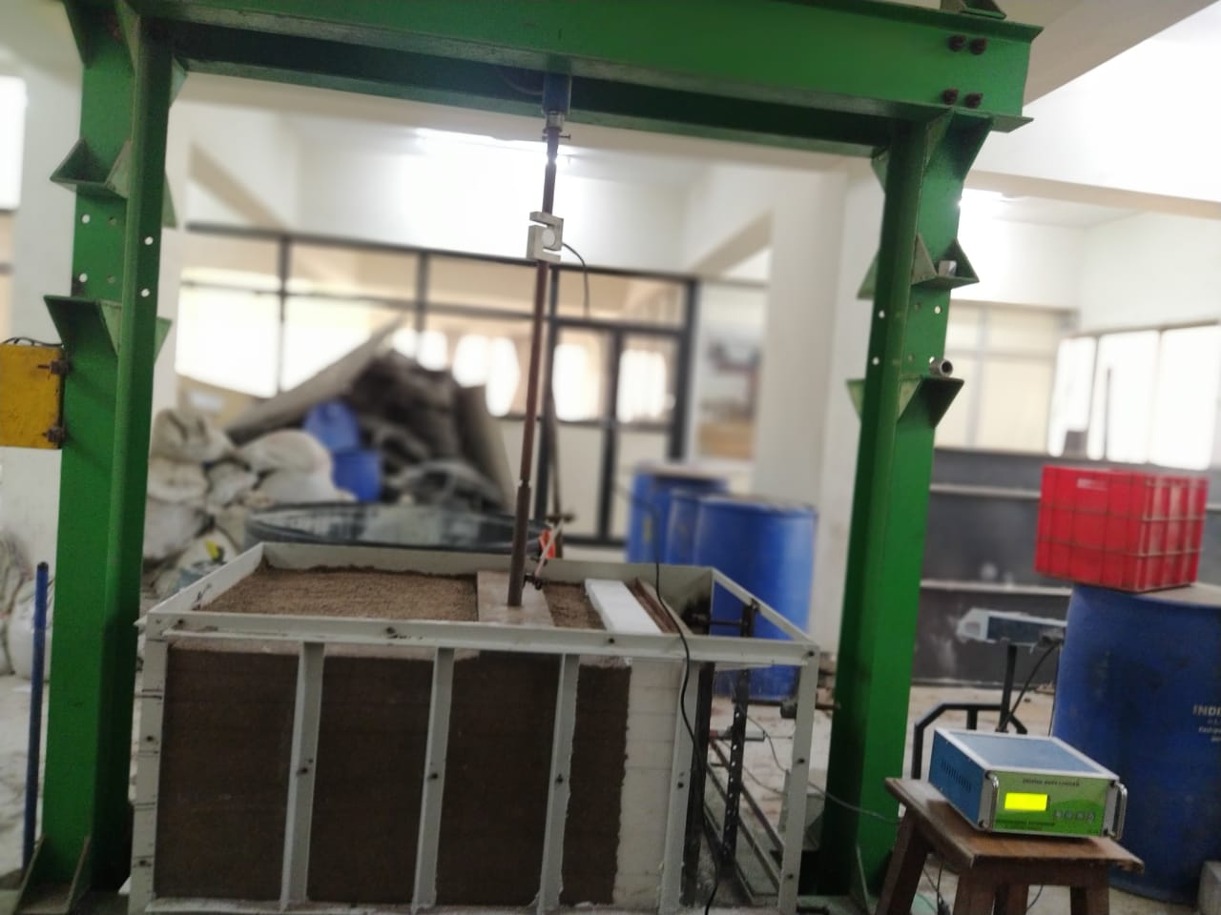
Figure 8 Loading Frame (10T Capacity)
Reaction frame and model tank with Load Cell & LVDT: -
Loading frame of 5 T capacities and tank of size 1.25m x1.25m x0.9 m (size of the tank can be varied based on the need of the experiments). Load cell (S type - 2 Nos.), LVDT (3 Nos.) and 8 channel read out unit.
These equipments are used to measure;
- The load settlement behavior of unreinforced and reinforced footing.
- Compression and uplift capacity of pile, granular pile and composite pile.
- Tensile capacity of granular pile anchor and helical pile anchor.
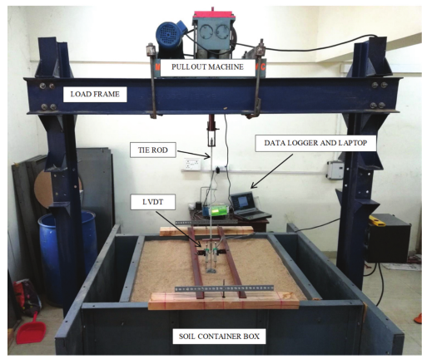
Figure 9 Reaction frame and model tank with Load Cell & LVDT

